**BANKING AND SHOPPING**

* 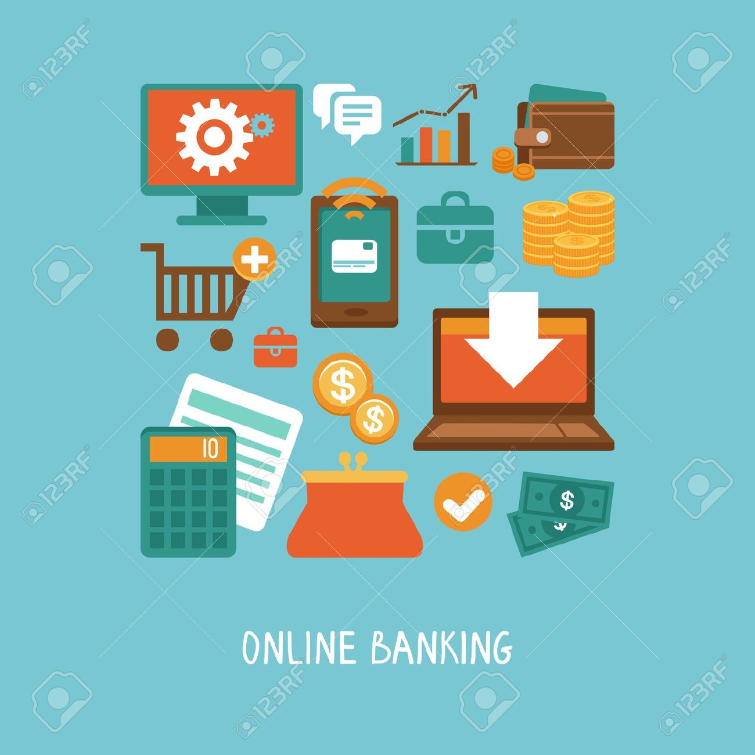Nowadays banking and shopping have been made easier by the introduction of the internet, despite the security issue these services are growing rapidly.
* Shopping online is one of the easiest things to do. It has been a great success due to the customers sending back positive feedback, the purchase of items has become easier because all that is needed is the provision of the customer’s credit card details. Since customers can rely on their credit cards the purchase is done without the physical transaction.
* All the customer has to do is browse the internet and select their desired products. All the credit card credentials are put at the end of the transaction over a secure webpage.
* ***Socially*** people have not been affected in a large way no social aspects of life have not been interfered with, apart from the interaction with others and the tellers at the counter.
* ***Personally*** life has become much simpler now that anything and everything can be purchased and bank transactions can be carried out without any physical presence. We are able to save time from standing in the long lines at the bank and hustles of going all the way to the stores to buy their items, and the customer is able to know what is out of stock and what isn’t.
* ***Professionally*** shopping does not have any effect on the corporate world. But banking has greatly affected banks and all the workers, due to the flexibility of the bank transactions most of the work is done anywhere or at any time. Very few people are needed to manage the online bank transactions, saving the bank on employment costs and any other costs incurred from the normal/physical banking.
* Some drawbacks of shopping online are having to deal with counterfeit goods or having to return items due to the wrong order. Banking online also has some drawbacks for instance having insecurities about the information provided online.